Step 1

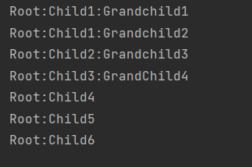

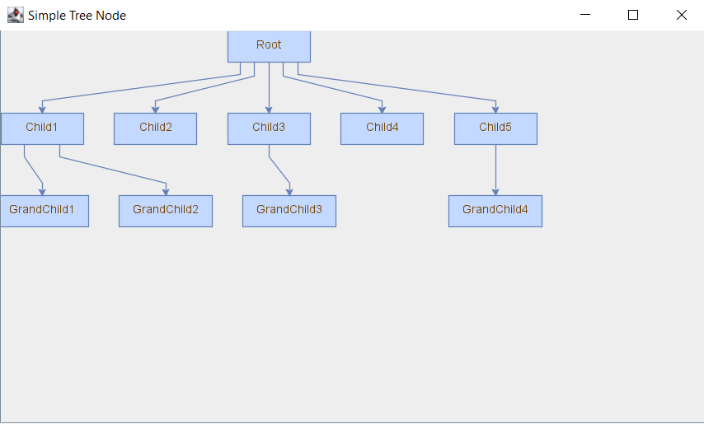

Step 2

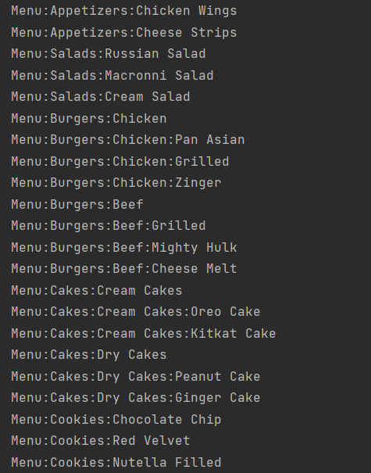

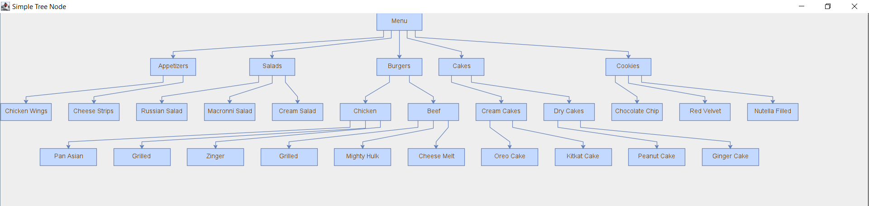

# Narrative

I have made a menu for a restaurant which has categories like appetizer, cakes etc. and subcategories or items for each. The menu has been perfectly organized in hierarchy using tree as can be seen above. We have a root node named as ‘Menu’ which as following categories:

* Appetizer
* Salads
* Burgers
* Cakes
* Cookies

Some of these categories have items and others have more subcategories like cakes, burger.

For **Appetizer** we have following items:

* Chicken Wings
* Cheese Strips

For **Salads** we have following items:

* Russian Salad
* Macronni Salad
* Cream Salad

For **Burgers**, we have following subcategories along with items:

* Chicken
  + Grilled
  + Pan Asian
  + Zinger
* Beef
  + Grilled
  + Cheese Melt
  + Mighty Hulk

For **Cakes**, we have following subcategories along with items:

* Cream Cakes
  + Oreo Cake
  + Kitkat Cake
* Dry Cakes
  + Peanut Cake
  + Ginger Cake

For **Cookies**, we have following items:

* Chocolate Chip
* Red Velvet
* Nutella Filled

I have learned how trees can be used in real life examples and how much convenient and easy they make certain task. To show hierarchy, groups, subgroups neatly, trees are used. Apart from binary tree, I know what a generic tree is and how it works.